**CSA1443- Compiler Design for Intraprocedural Analysis**

**192371068 D NAVADEEP**

**LEX PROGRAMS –(23 TO 25)**

**21)** **Write a LEX program to identify the capital words from the given input.**

**Aim:**

To develop a LEX program that identifies and prints all capital words from the given input.

**Code:**

%{

#include<stdio.h>

%}

%%

[A-Z]+[\t\n ] { printf("%s",yytext); }

. ;

%%

Int yywrap(){}

int main( )

{

printf("Enter the input string:\n");

yylex();

}

**Output:**

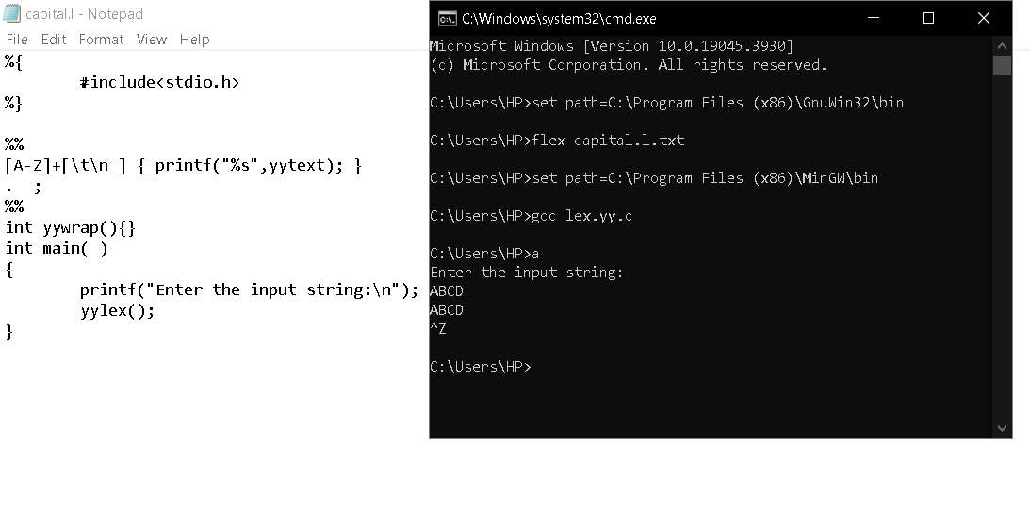

**22. Validate Email Address**

**Aim:**To implement a LEX program that checks whether a given email address follows a valid format using pattern matching.

**Code:**

%{

%}

%%

[a-z.0-9_]+@[a-z]+".com"|".in" { printf(“it is valid”);}

.+ { printf(“it is not valid”);}

%%

int yywrap(){}

int main()

{

printf("enter the mail:");

yylex();

}

**Output:**

